**Lesson 05 Demo 03**

**Automating Boilerplate Code generation with   
GitHub Copilot**

**Objective:** To demonstrate the automation of boilerplate code generation in a college management system using GitHub Copilot, specifically focusing on creating standard   
API endpoints

**Tools required:** Visual Studio Code, node js, json-server, and GitHub Copilot

**Prerequisites:** Lesson 05 Demos 01 and 02

Steps to be followed:

1. Input a specific endpoint creation prompt
2. Based upon prompt message whatever code generate follow all these steps and make the project ready.
3. Test the application.

**Note**: The generative AI tool used in this exercise can produce varied outputs even when presented with similar prompts. Thus, you may get different outputs for the same prompt.

**Step 1: Input a specific endpoint creation prompt**

* 1. First create the folder with name as **react-demo-api-app**
  2. Open this folder in vs code.
  3. Open Visual Studio and provide the following prompt to GitHub Copilot:   
     **“The project is based on React JS using axios module to interact with emp.json file which is running using json-sever module and provide the end point. All the REST endpoints follow camelCasing for the URL paths. The emp.json file is as follows: departments with attribute [id, departmentName] and students with columns [id, StudentName, departmentId]. Create an API store and retrieve department and student details using react js. Please provide these provide all steps in details.”**

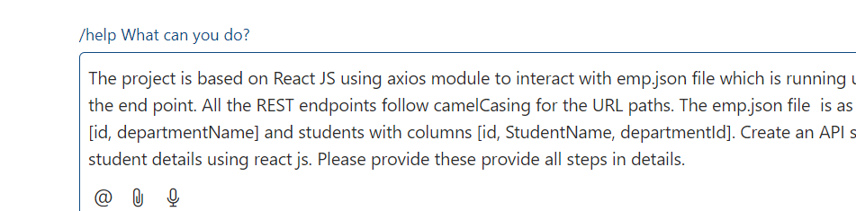

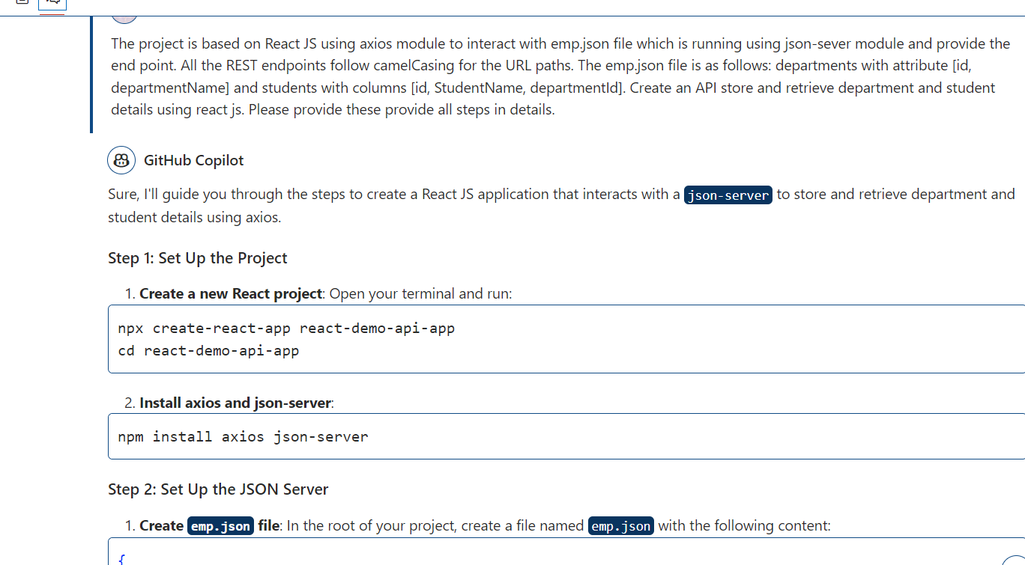

**Step 2.** Based upon prompt message whatever code generate follow all these steps and make the project ready.

**2.1 Set Up the Project**

1. **Initialize a new React project:**

**Note :**  We will create the react js project using new version with vite framework.



**npm create vite@latest react-demo-api-app --template react**

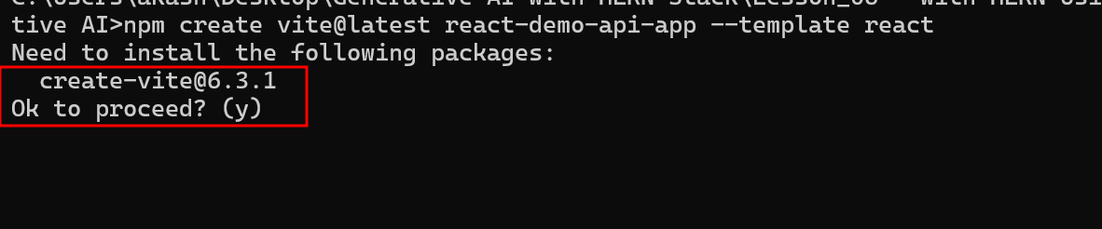

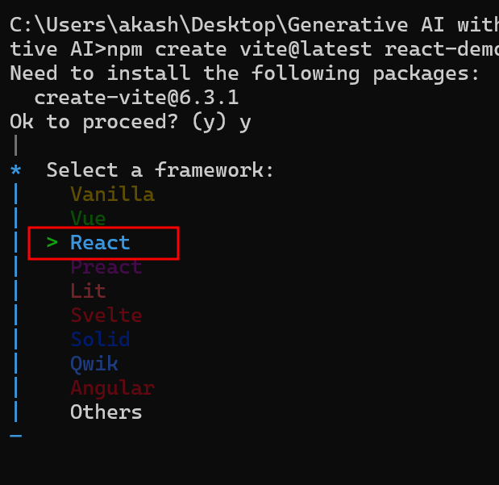

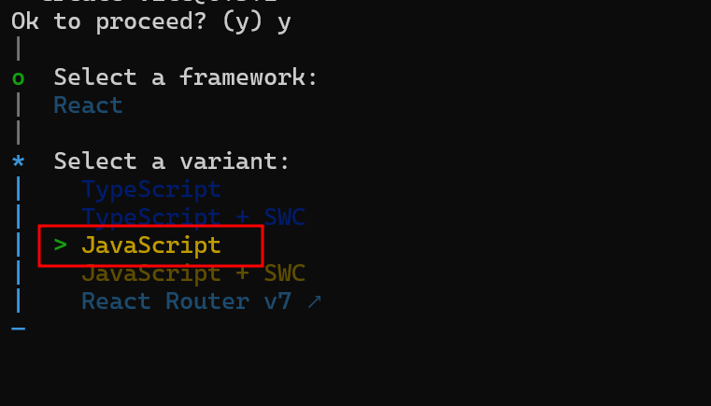

**After project created move inside a project directory**

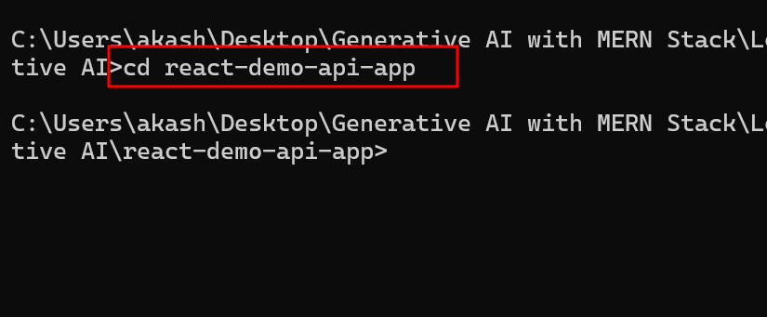

and run the command as **npm install**

it helps to install required react and vite framework dependencies

2.3 Now need to installed required external dependencies.

**npm install axios json-serve**

2.4 Now we will create the **sms.json** file

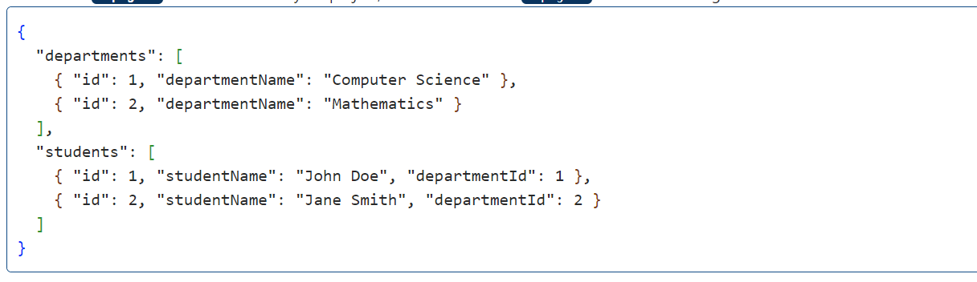

Apply this sample file in editor.

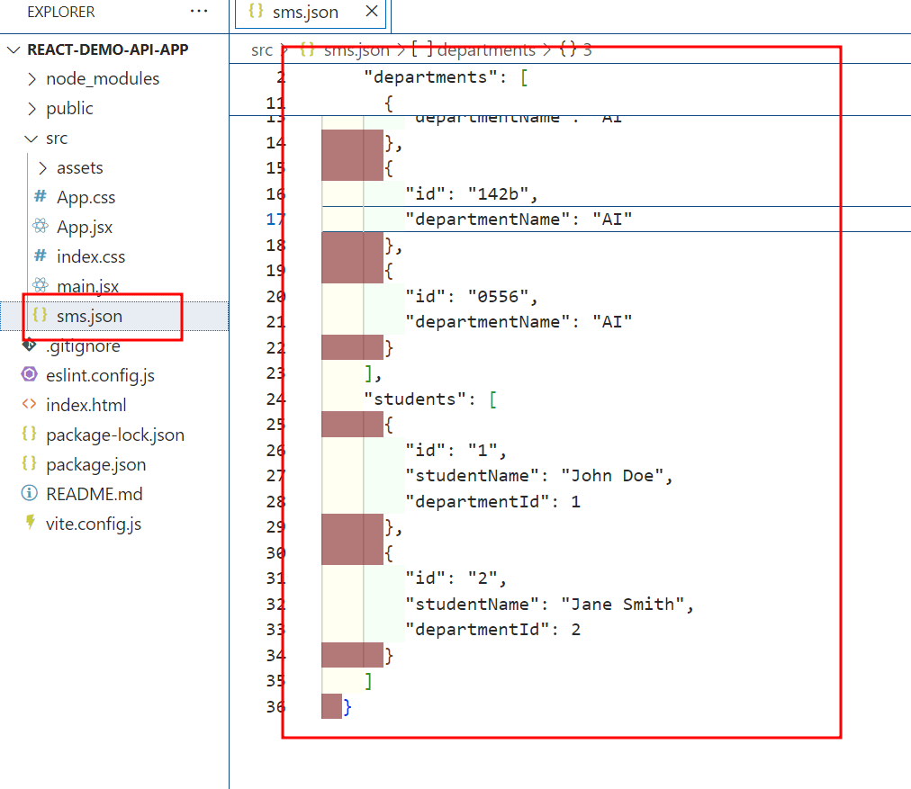

2.5 apply generate package.json sever code to existing package.json code

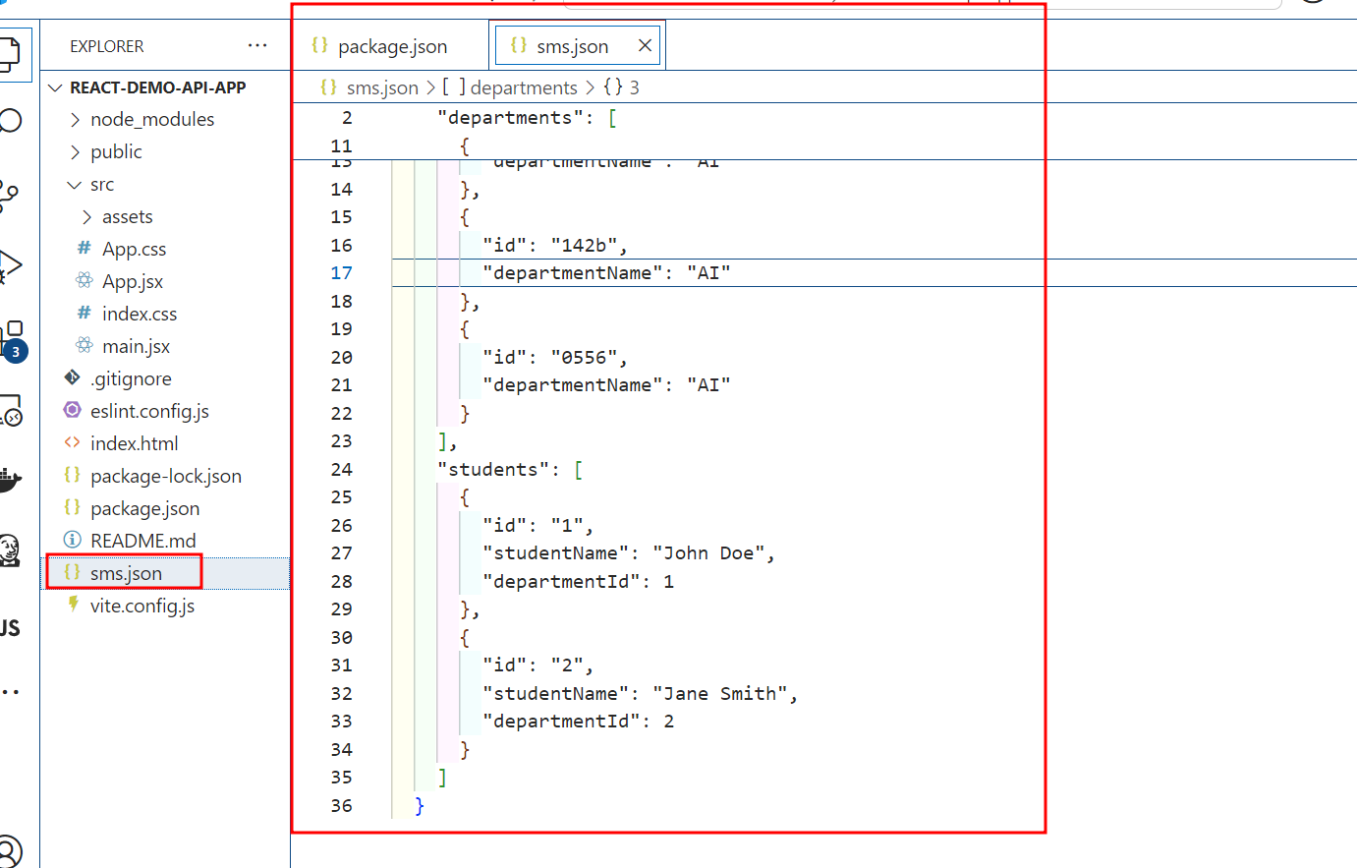

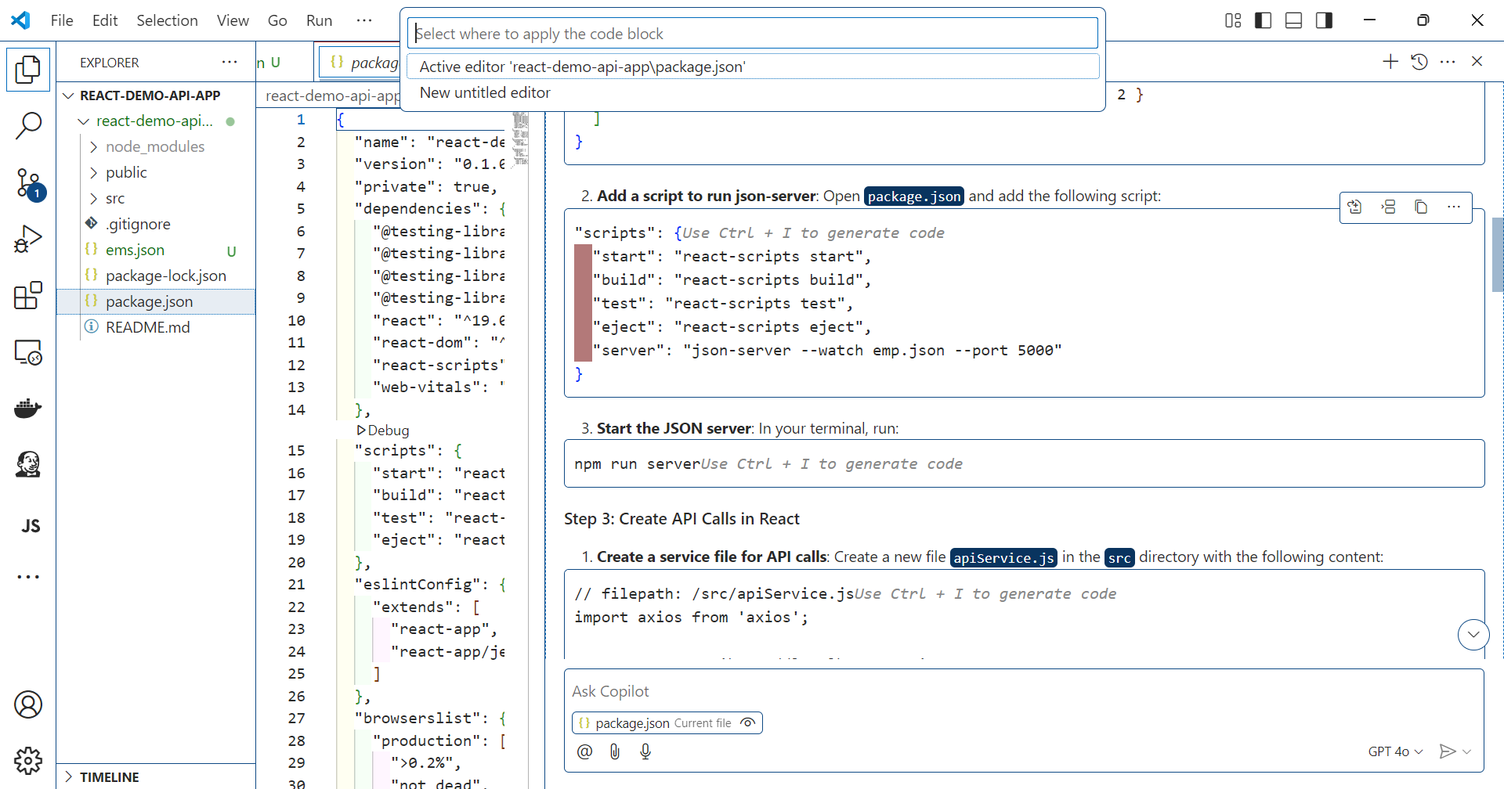

2.6 **Start the JSON server**: In your terminal, run:

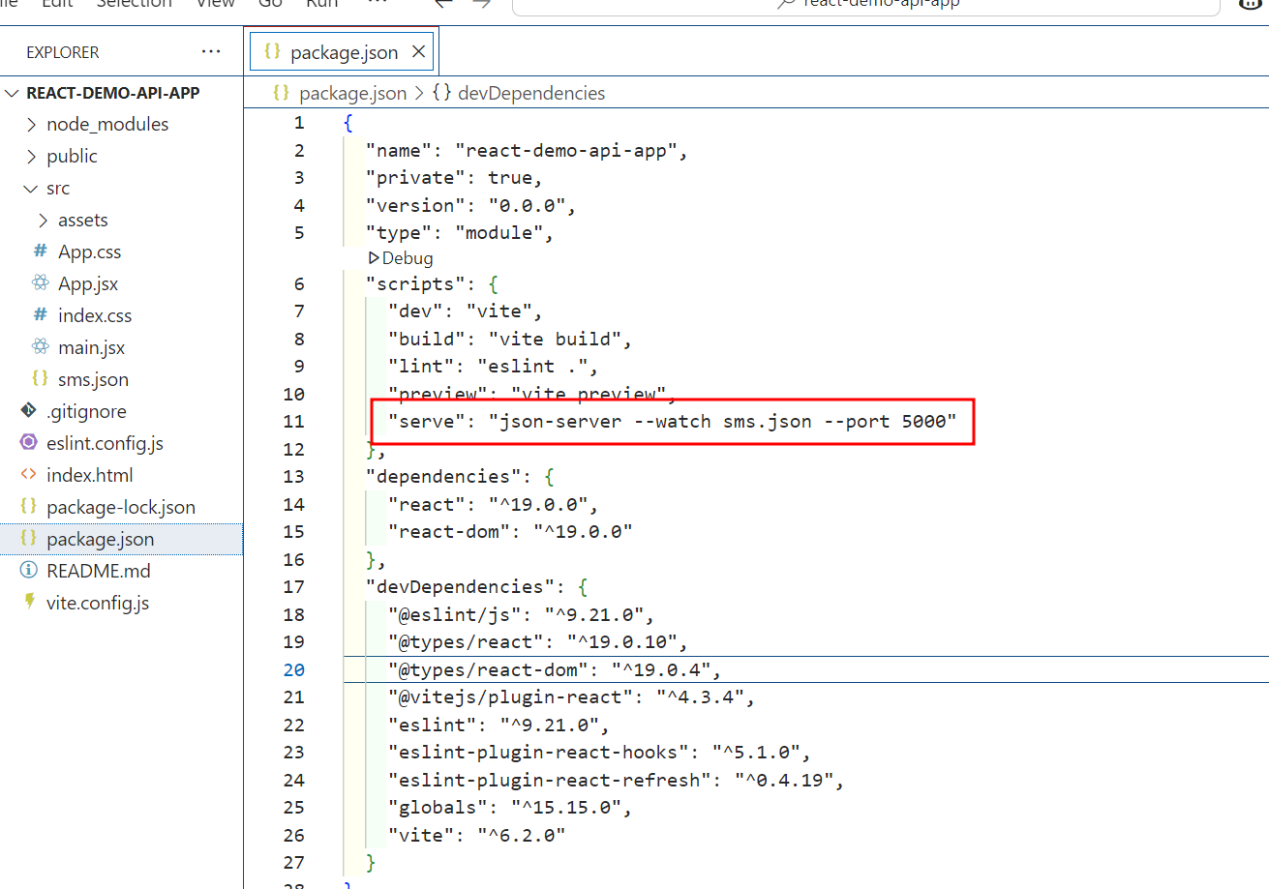

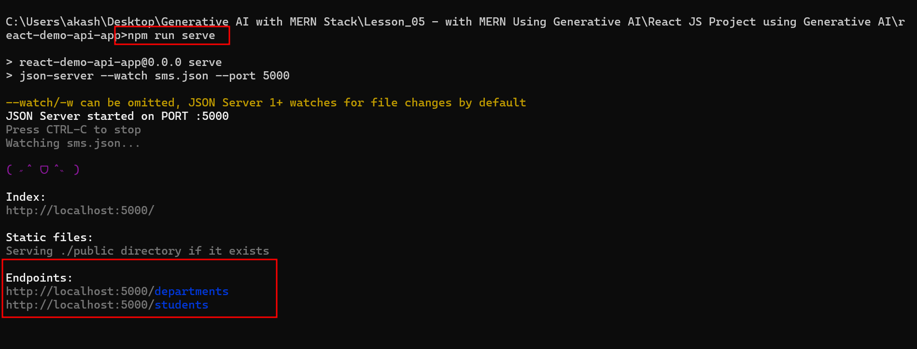

2.7 create API call in react js.

**apiService.js**

// filepath: /src/apiService.js

import axios from 'axios';

const API_URL = 'http://localhost:5000';

export const getDepartments = async () => {

const response = await axios.get(`${API_URL}/departments`);

return response.data;

};

export const getStudents = async () => {

const response = await axios.get(`${API_URL}/students`);

return response.data;

};

export const addDepartment = async (department) => {

const response = await axios.post(`${API_URL}/departments`, department);

return response.data;

};

export const addStudent = async (student) => {

const response = await axios.post(`${API_URL}/students`, student);

return response.data;

};

Apply this code to editor and save with file name as **apiService.js** inside src folder.

2.8 **Create Components to Display Data**

**Create a Departments component**: Create a new file **Departments.jsx** in the src directory with the following content:

**Department.jsx**

// filepath: /src/Departments.jsx

import React, { useEffect, useState } from 'react';

import { getDepartments } from './apiService';

const Departments = () => {

  const [departments, setDepartments] = useState([]);

  useEffect(() => {

    const fetchDepartments = async () => {

      const data = await getDepartments();

      setDepartments(data);

    };

    fetchDepartments();

  }, []);

  return (

    <div>

      <h2>Departments</h2>

      <ul>

        {departments.map(department => (

          <li key={department.id}>{department.departmentName}</li>

        ))}

      </ul>

    </div>

  );

};

export default Departments;

2.9 **Create a Students component**: Create a new file Students.js in the src directory with the following content:

**Students.jsx**

// filepath: /src/Students.jsx

import React, { useEffect, useState } from 'react';

import { getStudents } from './apiService';

const Students = () => {

  const [students, setStudents] = useState([]);

  useEffect(() => {

    const fetchStudents = async () => {

      const data = await getStudents();

      setStudents(data);

    };

    fetchStudents();

  }, []);

  return (

    <div>

      <h2>Students</h2>

      <ul>

        {students.map(student => (

          <li key={student.id}>{student.studentName}</li>

        ))}

      </ul>

    </div>

  );

};

export default Students;

* 1. **Integrate Components in App**

**Update App.jsx**: Open src/App.jsx and update it to include the new components:

**App.jsx**

// filepath: /src/App.jsx

import React from 'react';

import Departments from './Departments';

import Students from './Students';

function App() {

  return (

    <div className="App">

      <header className="App-header">

        <h1>React Demo API App</h1>

        <Departments />

        <Students />

      </header>

    </div>

  );

}

export default App;

2.11 : If you need to add Add operation on Student and Department ask for the prompt message.

“please provide the code for add Student and deparment must be react js component”

2.12 **Create AddDepartment.jsx**: Create a new file AddDepartment.jsx in the src directory with the following content:

**AddDepartmentx.js**

// filepath: /src/AddDepartmentx.js

import React, { useState } from 'react';

import { addDepartment } from './apiService';

const AddDepartment = () => {

  const [departmentName, setDepartmentName] = useState('');

  const handleSubmit = async (e) => {

    e.preventDefault();

    const newDepartment = { departmentName };

    await addDepartment(newDepartment);

    setDepartmentName('');

  };

  return (

    <div>

      <h2>Add Department</h2>

      <form onSubmit={handleSubmit}>

        <input

          type="text"

          value={departmentName}

          onChange={(e) => setDepartmentName(e.target.value)}

          placeholder="Department Name"

          required

        />

        <button type="submit">Add Department</button>

      </form>

    </div>

  );

};

export default AddDepartment;

2.13 **Create AddStudent Component**

**Create AddStudent.jsx**: Create a new file AddStudent.js in the src directory with the following content:

// filepath: /src/AddStudent.jsx

import React, { useState, useEffect } from 'react';

import { addStudent, getDepartments } from './apiService';

const AddStudent = () => {

  const [studentName, setStudentName] = useState('');

  const [departmentId, setDepartmentId] = useState('');

  const [departments, setDepartments] = useState([]);

  useEffect(() => {

    const fetchDepartments = async () => {

      const data = await getDepartments();

      setDepartments(data);

    };

    fetchDepartments();

  }, []);

  const handleSubmit = async (e) => {

    e.preventDefault();

    const newStudent = { studentName, departmentId: parseInt(departmentId) };

    await addStudent(newStudent);

    setStudentName('');

    setDepartmentId('');

  };

  return (

    <div>

      <h2>Add Student</h2>

      <form onSubmit={handleSubmit}>

        <input

          type="text"

          value={studentName}

          onChange={(e) => setStudentName(e.target.value)}

          placeholder="Student Name"

          required

        />

        <select

          value={departmentId}

          onChange={(e) => setDepartmentId(e.target.value)}

          required

        >

          <option value="">Select Department</option>

          {departments.map(department => (

            <option key={department.id} value={department.id}>

              {department.departmentName}

            </option>

          ))}

        </select>

        <button type="submit">Add Student</button>

      </form>

    </div>

  );

};

export default AddStudent;

2.14 **Integrate Components in App**

**Update**[App.js](vscode-file://vscode-app/c:/Users/akash/AppData/Local/Programs/Microsoft%20VS%20Code/resources/app/out/vs/code/electron-sandbox/workbench/workbench.html)x: Open [App.js](vscode-file://vscode-app/c:/Users/akash/AppData/Local/Programs/Microsoft%20VS%20Code/resources/app/out/vs/code/electron-sandbox/workbench/workbench.html)x and update it to include the new components:

// filepath: /src/Appx.js

import React from 'react';

import './App.css';

import Departments from './Departments';

import Students from './Students';

import AddDepartment from './AddDepartment';

import AddStudent from './AddStudent';

function App() {

  return (

    <div className="App">

      <header className="App-header">

        <h1>React Demo API App</h1>

        <AddDepartment />

        <AddStudent />

        <Departments />

        <Students />

      </header>

    </div>

  );

}

export default App;

**Step 3 : Run this application**

npm run dev **(this command you need to run on another terminal)**

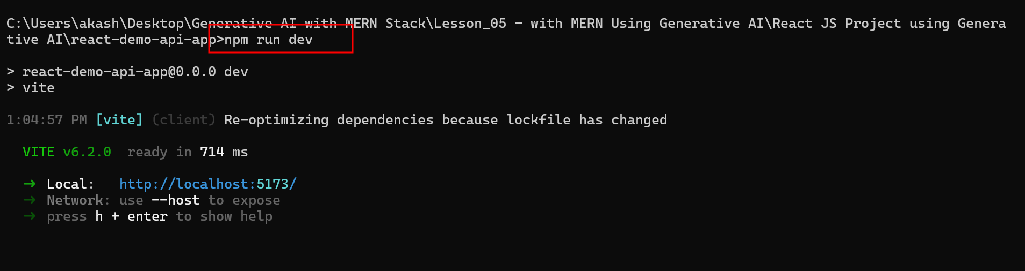

You can see the output on browser as

